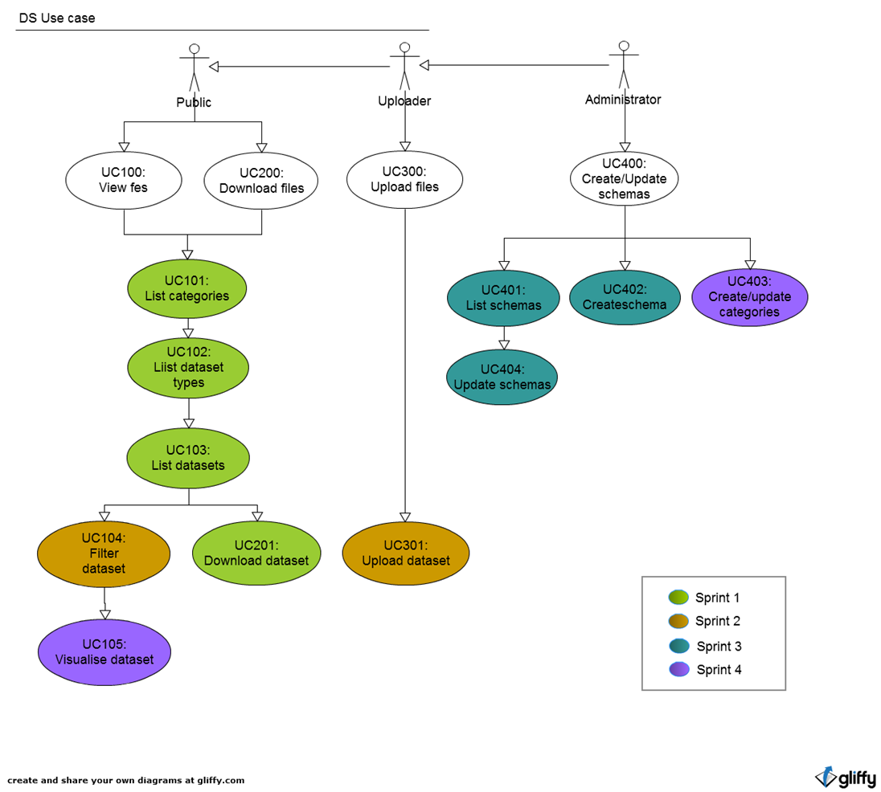

**Rough sprint overview**

**Sprint 1:  Download dataset**

|  |  |
| --- | --- |
| **Functionality** | **Estimate** |
| * List categories (UC101) * List dataset types (UC102) * List datasets (UC103) * Download dataset (UC201) | 4 weeks |

**DS (Sprint 2) Upload/filter dataset**

|  |  |
| --- | --- |
| **Functionality** | **Estimate** |
| * Update to categories and dataset listing pages (UC101, UC102, UC103) * Upload dataset with revisions (UC301) * Filter dataset (UC104) | 4-6 weeks depending on data validation |

**DS (Sprint 3) Create upload schema**

|  |  |
| --- | --- |
| **Functionality** | **Estimate** |
| Download file   * List schemas (UC401) * Create schema (UC402) * Update schema (UC404) | 6-8 weeks |

**DS (Sprint 4) Data visualisations**

|  |  |
| --- | --- |
| **Functionality** | **Estimate** |
| Download file   * Update categories (UC403) * Visualise dataset(charting and mapping) (UC105) | 4-6 weeks |